**Create ASP.NET Core MVC Project**

On the Visual Studio, create new ASP.NET Core MVC Web Application project

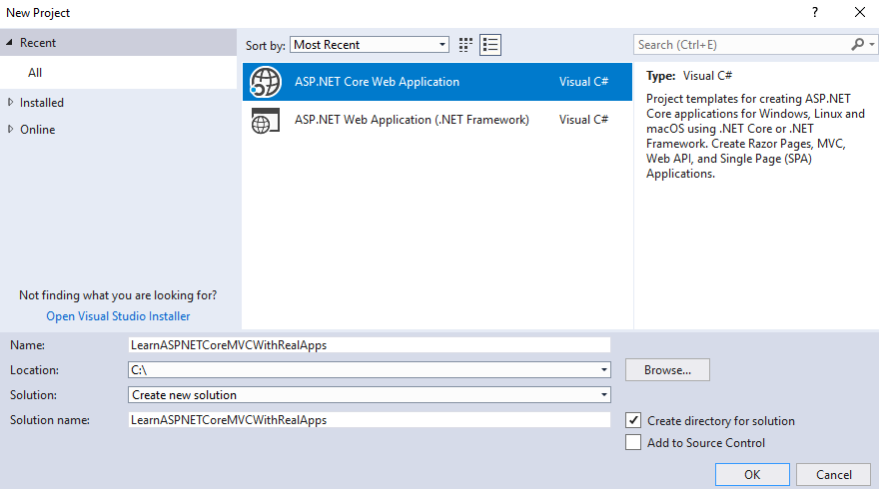

Select **Empty** Template

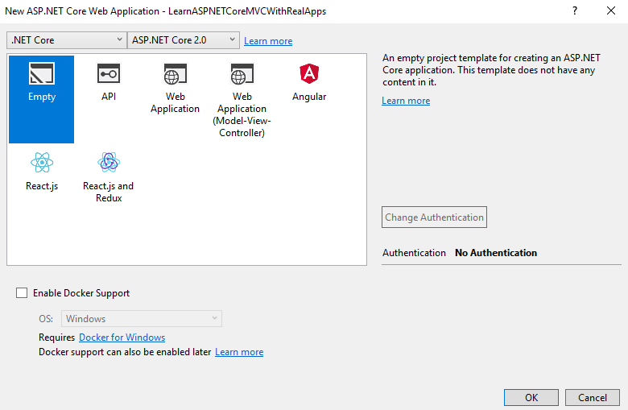

Click **Ok** button to Finish

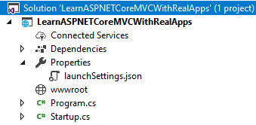

**Add Image Files**

Create new folder named **images** in **wwwroot** folder. Copy images need to use in project to **images** folder.

**Add Configurations**

Open **Startup.cs** file and add new configurations as below:

using System;

using System.Collections.Generic;

using System.Linq;

using System.Threading.Tasks;

using Microsoft.AspNetCore.Builder;

using Microsoft.AspNetCore.Hosting;

using Microsoft.AspNetCore.Http;

using Microsoft.Extensions.DependencyInjection;

namespace LearnASPNETCoreMVCWithRealApps

{

public class Startup

{

public void ConfigureServices(IServiceCollection services)

{

services.AddMvc();

services.AddSession();

}

public void Configure(IApplicationBuilder app, IHostingEnvironment env)

{

if (env.IsDevelopment())

{

app.UseDeveloperExceptionPage();

}

app.UseSession();

app.UseStaticFiles();

app.UseMvc(routes =>

{

routes.MapRoute(

name: "default",

template: "{controller=Demo}/{action=Index}/{id?}");

});

}

}

}

**Entities Class**

Create new folder named **Models**. In **Models** folder, create new entities class as below:

**Product Entity**

Create new class named **Product.cs** as below:

using System;

using System.Collections.Generic;

using System.Linq;

using System.Threading.Tasks;

namespace LearnASPNETCoreMVCWithRealApps.Models

{

public class Product

{

public string Id { get; set; }

public string Name { get; set; }

public double Price { get; set; }

public string Photo { get; set; }

}

}

**Item Entity**

Create new class named **Item.cs** as below:

using System;

using System.Collections.Generic;

using System.Linq;

using System.Threading.Tasks;

namespace LearnASPNETCoreMVCWithRealApps.Models

{

public class Item

{

public Product Product { get; set; }

public int Quantity { get; set; }

}

}

**Create Session Helper**

Create new folder named **Helpers**. In this folder, create new helper named **SessionHelper.cs** as below:

using Microsoft.AspNetCore.Http;

using Newtonsoft.Json;

using System;

using System.Collections.Generic;

using System.Linq;

using System.Threading.Tasks;

namespace LearnASPNETCoreMVCWithRealApps.Helpers

{

public static class SessionHelper

{

public static void SetObjectAsJson(this ISession session, string key, object value)

{

session.SetString(key, JsonConvert.SerializeObject(value));

}

public static T GetObjectFromJson<T>(this ISession session, string key)

{

var value = session.GetString(key);

return value == null ? default(T) : JsonConvert.DeserializeObject<T>(value);

}

}

}

**Create Controller**

Create new folder named **Controllers**. In this folder, create new controllers as below:

**ProductController**

Create new class named **ProductController.cs** as below:

using System;

using System.Collections.Generic;

using System.Linq;

using System.Threading.Tasks;

using LearnASPNETCoreMVCWithRealApps.Models;

using Microsoft.AspNetCore.Mvc;

namespace LearnASPNETCoreMVCWithRealApps.Controllers

{

[Route("product")]

public class ProductController : Controller

{

[Route("")]

[Route("index")]

[Route("~/")]

public IActionResult Index()

{

ProductModel productModel = new ProductModel();

ViewBag.products = productModel.findAll();

return View();

}

}

}

**CartController**

Create new class named **CartController.cs**, this file contains contains the operation methods on the [Shopping Cart](https://amzn.to/2QXyKCb) as below:

using System;

using System.Collections.Generic;

using System.Linq;

using System.Threading.Tasks;

using LearnASPNETCoreMVCWithRealApps.Models;

using Microsoft.AspNetCore.Mvc;

using Microsoft.AspNetCore.Http;

using LearnASPNETCoreMVCWithRealApps.Helpers;

namespace LearnASPNETCoreMVCWithRealApps.Controllers

{

[Route("cart")]

public class CartController : Controller

{

[Route("index")]

public IActionResult Index()

{

var cart = SessionHelper.GetObjectFromJson<List<Item>>(HttpContext.Session, "cart");

ViewBag.cart = cart;

ViewBag.total = cart.Sum(item => item.Product.Price * item.Quantity);

return View();

}

[Route("buy/{id}")]

public IActionResult Buy(string id)

{

ProductModel productModel = new ProductModel();

if (SessionHelper.GetObjectFromJson<List<Item>>(HttpContext.Session, "cart") == null)

{

List<Item> cart = new List<Item>();

cart.Add(new Item { Product = productModel.find(id), Quantity = 1 });

SessionHelper.SetObjectAsJson(HttpContext.Session, "cart", cart);

}

else

{

List<Item> cart = SessionHelper.GetObjectFromJson<List<Item>>(HttpContext.Session, "cart");

int index = isExist(id);

if (index != -1)

{

cart[index].Quantity++;

}

else

{

cart.Add(new Item { Product = productModel.find(id), Quantity = 1 });

}

SessionHelper.SetObjectAsJson(HttpContext.Session, "cart", cart);

}

return RedirectToAction("Index");

}

[Route("remove/{id}")]

public IActionResult Remove(string id)

{

List<Item> cart = SessionHelper.GetObjectFromJson<List<Item>>(HttpContext.Session, "cart");

int index = isExist(id);

cart.RemoveAt(index);

SessionHelper.SetObjectAsJson(HttpContext.Session, "cart", cart);

return RedirectToAction("Index");

}

private int isExist(string id)

{

List<Item> cart = SessionHelper.GetObjectFromJson<List<Item>>(HttpContext.Session, "cart");

for (int i = 0; i < cart.Count; i++)

{

if (cart[i].Product.Id.Equals(id))

{

return i;

}

}

return -1;

}

}

}

**Create View**

Create new folder named **Views**. In this folder, create new [razor](https://amzn.to/2QW2Aa9) views as below:

**Product View**

Create new folder named **Product**. In **Product** folder, create new view named **Index.cshtml** as below:

@{

Layout = null;

}

<!DOCTYPE html>

<html>

<head>

<meta name="viewport" content="width=device-width" />

<title>Index</title>

</head>

<body>

<h3>Products List</h3>

<table cellpadding="2" cellspacing="2" border="1">

<tr>

<th>Id</th>

<th>Name</th>

<th>Photo</th>

<th>Price</th>

<th>Buy</th>

</tr>

@foreach (var product in ViewBag.products)

{

<tr>

<td>@product.Id</td>

<td>@product.Name</td>

<td><img src="~/images/@product.Photo" width="60" /> </td>

<td>@product.Price</td>

<td align="center">

<a asp-controller="cart" asp-action="buy" asp-route-id="@product.Id">Buy Now</a>

</td>

</tr>

}

</table>

</body>

</html>

**Cart Views**

Create new folder named **Cart**. In **Cart** folder, create new view named **Index.cshtml** as below:

@{

Layout = null;

}

<!DOCTYPE html>

<html>

<head>

<meta name="viewport" content="width=device-width" />

<title>Index</title>

</head>

<body>

<h3>Cart Page</h3>

<table cellpadding="2" cellspacing="2" border="1">

<tr>

<th>Option</th>

<th>Id</th>

<th>Name</th>

<th>Photo</th>

<th>Price</th>

<th>Quantity</th>

<th>Sub Total</th>

</tr>

@foreach (var item in ViewBag.cart)

{

<tr>

<td><a asp-controller="cart" asp-action="remove" asp-route-id="@item.Product.Id">Remove</a></td>

<td>@item.Product.Id</td>

<td>@item.Product.Name</td>

<td><img src="~/images/@item.Product.Photo" width="60" /> </td>

<td>@item.Product.Price</td>

<td>@item.Quantity</td>

<td>@(item.Product.Price * item.Quantity)</td>

</tr>

}

<tr>

<td align="right" colspan="6">Sum</td>

<td>

@ViewBag.total

</td>

</tr>

</table>

<br>

<a asp-controller="product" asp-action="index">Continue Shopping</a>

</body>

</html>

**Create Razor View Imports**

Select **Views** folder and right click to select **Add\New Item** Menu

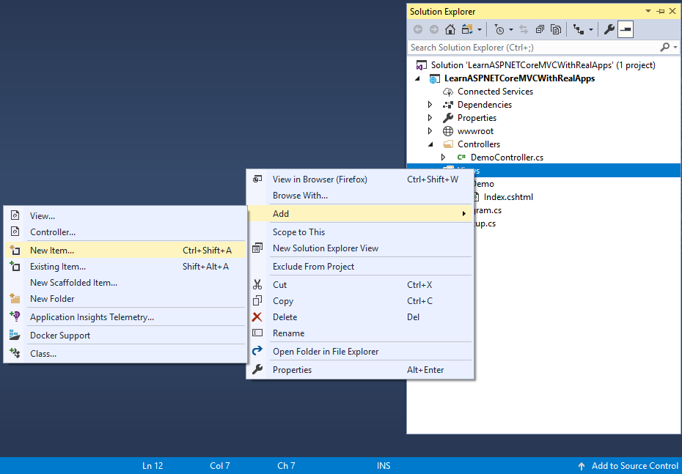

Select **Web\ASP.NET** in left side. Select **Razor View Imports** item and click **Add** button to Finish

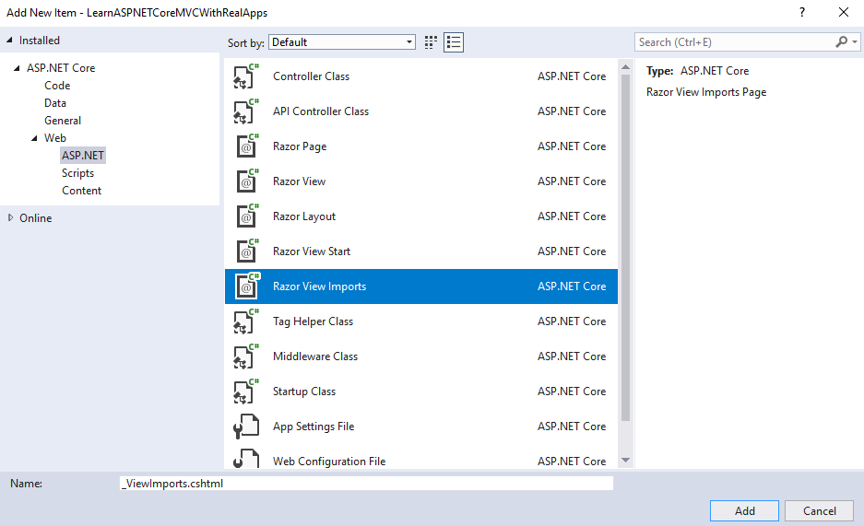

In **_ViewImports.cshtml** file and **TagHelpers** library as below:

@addTagHelper *, Microsoft.AspNetCore.Mvc.TagHelpers

**Structure of ASP.NET Core MVC Project**

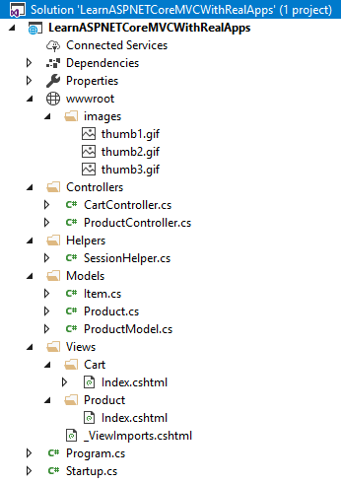

**Run Application**

Access **Index** action in **Product** controller with following url: **http://localhost:48982**

**Output**

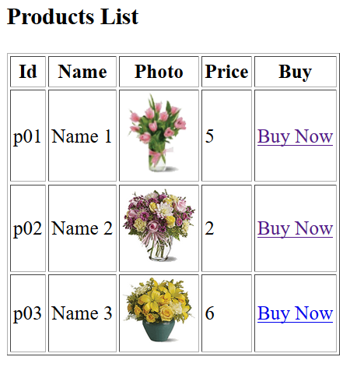

Click **Buy Now** link from product page to buy a product and show it in cart page

